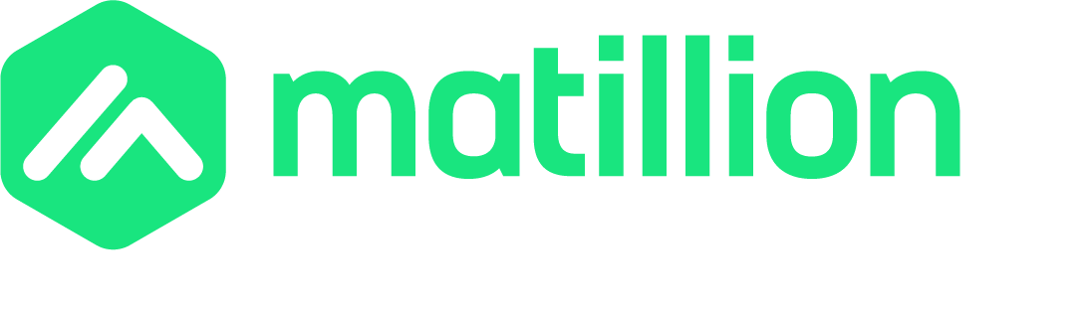
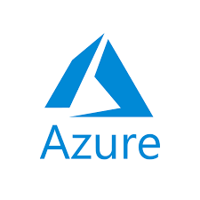
Azure Agent Setup
Objective:
The Data Productivity Cloud Agent is an integral part of the Data Productivity Cloud framework. It functions as a connector between the user's data environment and the centralized platform, facilitating the execution and scheduling of compatible pipelines.

Prerequisites
- To provision cloud resources and manage access control in the Azure environment, an Azure subscription with the necessary permissions is required. This includes managing resource groups, virtual networks, key vaults, and container apps.
- Ensure a suitable resource group is already defined in the Azure environment. If it does not exist, follow the instructions provided below to create one.
- A suitable virtual network is also needed in the Azure environment to secure access between the agent and other resources, limiting the scope of access. The virtual network must:
  - Be fully configured as desired, including routing to on-premises resources.
  - Allow egress to Matillion's Data Productivity Cloud IP ranges.
  - Have room for one additional subnet with at least a /27 IP range.
Note: For the agent, a /27 IP range provides enough usable IPs for agent container replicas during normal operation and allows extra IPs for new nodes during a rolling restart/update. Refer to the Azure documentation on environment selection for further details.
- Optionally, a suitable key vault can be defined in the environment. This is not mandatory, as the installation process will create a new key vault by default.
- Minimum permissions required include the ability to:
Create:
- Subnet
- Managed identity
- Key Vault
- Log Analytics Workspace
- Container App & Container App Environment
Modify:
- Subnet delegation
Permissions:
- Role assignments in the resource group
- Key Vault
To deploy the agent using the ARM template, specific Azure permissions are necessary. Assistance from the organization's cloud administrator might be required to obtain these permissions.

- Here is a summary of the required permissions:
Resource Group:
- Contributor or Owner role to create and manage resource groups.
Virtual Network:
- Network Contributor role to create and manage virtual networks and subnets.
Key Vault:
- Key Vault Contributor role to create key vaults.
- Key Vault Secrets User role for the agent's managed identity to list and get secret values.
- Key Vault Administrator or Key Vault Secrets Officer role for other users to list and edit key vault secrets if the ARM template creates the key vault.
Managed Identity:
- Managed Identity Contributor role to create and manage managed identities.
Container App:
- Container App Contributor role to deploy and manage container apps.
Instructions for creating a resource group, virtual network, key vault, and NAT gateway if these resources do not already exist.
- Installations
- Create a Resource Group
An Azure resource group is needed to contain all the Azure resources for the agent. The agent deployment template will request the name of the resource group and create all resources there.
If a suitable existing resource group is not available, create a new one as follows:
- Log in to the Azure Portal.
- Use the search bar to search for "resource groups" and click the¹ result.
- On the Resource groups screen, click + Create.
- On the Create resource group screen, select the Subscription to be used for the agent from the drop-down.
- Enter a new name for the Resource group.
- Select an Azure Region for the resource group.
- If the organization mandates resource group tags, click Tags and assign tags as required.
- Click Review + Create, and then click Create if the resource group configuration is satisfactory.

- Create a Virtual Network
A virtual network is needed to secure access between the agent and other resources, reducing the scope of possible access.
If a suitable existing virtual network is not available, create a new one as follows:

- Log in to the Azure Portal.
- Use the search bar to search for "virtual networks" and click the result.
- On the Virtual Networks screen, click + Create.
- On the Create Virtual Network screen, select the resource group you created previously.
- Enter a new Virtual network name.
- Select an Azure Region for your virtual network. By default, this should be the same region as your resource group.
- If your organization mandates virtual network tags, click Tags and assign tags as required.
- Click Review + Create, and then click Create if you are satisfied with your virtual network configuration.
- On the Virtual Networks screen, locate the virtual network just created and click it.
- Click Service endpoints.
- Click + Add and select the required service endpoints from the Service drop-down. These are required if the subnet doesn't have access to the Internet (via Internet gateway or NAT gateway). At a minimum, the following service endpoints will be required:
Microsoft.KeyVault
Microsoft.Storage

- Select a subnet from the Subnets drop-down. The subnet must have been previously created via the Azure CLI using the following command:
az network vnet subnet create \
--resource-group <YourResourceGroup> \
--vnet-name <YourVNetName> \
--name <YourPrivateSubnetName> \
--address-prefix 10.0.2.0/27 \
--service-endpoints Microsoft.Storage Microsoft.KeyVault \
--delegations Microsoft.App/environments
- Click Add.

Create a Key Vault
The agent requires access to an Azure key vault. However, you don't need to create a key vault yourself; the deployment template will automatically create a key vault in the same resource group as the agent.

Alternatively, the agent can reference a pre-existing key vault. This key vault can reside in the same resource group or a different one. Referencing a key vault in a different resource group can be useful for allowing multiple agents to access the same secrets.
If an existing key vault is to be used, the configuration steps outlined in Configuring a key vault for Azure agent will need to be completed.

Create a NAT Gateway

- Log in to the Azure Portal.
- Use the search bar to search for "nat gateways" and click the result.
- Click Create NAT gateway.
- On the Basics tab, enter details of the Subscription, Resource group, and Region, ensuring that these match the details you have used for your virtual network. Enter a suitable Name for the gateway, and keep the suggested defaults for the Availability zone (No Zone) and TCP idle timeout (4 minutes).
- Click Next: Outbound IP.
- On the Outbound IP tab drop-down, click Create a new public IP address. Provide a Name for the IP address and click OK.
- Click Next: Subnet.
- On the Subnet tab, select the Virtual network containing the target subnet. In the list of subnets that appear, select the required subnet.
- If your organization mandates resource group tags, click Next: Tags and assign tags as required.
- Click Review + Create, and then click Create if you are satisfied with the configuration.

Completing the Installation

- Ensure you have created the appropriate prerequisites in your Azure environment.
- Add a Suitable Subnet
- Add a suitable subnet to the virtual network using the following command in the Azure CLI:
az network vnet subnet create \
--resource-group <YourResourceGroup> \
--vnet-name <YourVNetName> \
--name <YourPrivateSubnetName> \
--address-prefix 10.0.2.0/27 \
--service-endpoints Microsoft.Storage Microsoft.KeyVault \
--delegations Microsoft.App/environments
Note the subnet's full ID.

- Add a NAT Gateway (Optional)
- If desired, add a NAT gateway. Apply any security groups and user-defined routing that your network configuration may require, for example, to achieve connectivity to the Internet, Azure resources, and resources available via site-to-site VPN.
- Create a New Agent in Data Productivity Cloud
- In the Data Productivity Cloud, follow the steps to create a new agent, with Azure as the cloud provider and Container App as the deployment type.
- On the Agent details screen, click Reveal credentials in the Credentials section and note the client_id and client_secret.
- Click the Launch button in the Install using ARM section. This will open the Azure portal at the Custom Deployment page in a new browser tab.

Complete the following details on the Custom Deployment page:

Property | Description
Subscription | Select the subscription you will deploy the agent into.
Resource group | Select the resource group you created previously.
Region | Select the Azure region you will deploy the agent to, or leave the default value.
Create Key Vault | Select true to create a new key vault (recommended). Select false to use an existing key vault.
Agent Name | Enter a unique and descriptive name for the agent.
Location | This is set automatically by the template and shouldn't be changed.
Matillion Cloud Region | This is set automatically by the template and shouldn't be changed.
Container App Name | This is set automatically by the template and shouldn't be changed.
Default Key Vault | Enter the name of an existing key vault if using one. Otherwise, don't edit this field.
Default Key Vault Resource Group | Enter the name of the resource group for an existing key vault if using one. Otherwise, don't edit this field.
Subnet ID | Enter the ID of the subnet you created previously.
Account ID | This is set automatically by the template and shouldn't be changed.
Agent ID | This is set automatically by the template and shouldn't be changed.
Client ID | Enter the client_id credential obtained from the Agent details screen.
Client Secret | Enter the client_secret credential obtained from the Agent details screen.
Container Registry Username | This can be left blank.
Container Registry Password Secret Ref | This can be left blank.
Tags | Optionally, add any tags required by your organization's tagging policy. Tags should be added as a JSON string, for example: {"Category": "Development","Business Unit": "Data Pipelines","Owner": "owner@organization.com"}.

Optional Agent Parameters
The following properties are optional and should only be set if needed.

Property | Description
Proxy HTTP | If using a proxy, enter the HTTP proxy details. For example- http://myproxy.com:8080.
Proxy HTTPS | If using a proxy, enter the HTTPS proxy details. For example- https://myproxy.com:8443.
Proxy Excludes | If using a proxy, specify any addresses to exclude. Separate a list of addresses with the pipe character `
Custom Certificate Location | If using custom certificates, specify the storage location. For example: my_storage/my_certs.
Extension Library Location | Specify the location of any additional Python libraries you want to use.
External Driver Location | Specify the location of any external driver files you want to use.

- Click Review & Create.

It will take at least 10 minutes for the container app to be created and the Data Productivity Cloud agent application to load and initialize.

Return to the Agents screen in the Data Productivity Cloud, and ensure that the agent's status is Running.

Note: The developer should have a Contributor or Owner role to create and manage resource groups.

